How to write a basic paragraph
Step 1: Brainstorm and use a thinking map  Create a circle map and brainstorm all the details you can think of for the topic.  Circle the details you can explain more about. | 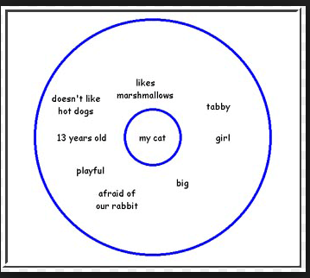
Step 2: Create the body boxes of a flow map.  Write the three details in the box. Then explain each detail by writing an example, clarifying sentences, or explain the detail some more. | 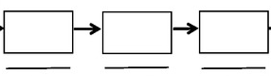
Step 3: draw the Topic sentence and concluding sentence boxes.  Write the main idea or topic sentence in the top box. Restate your topic sentence in your concluding box. | 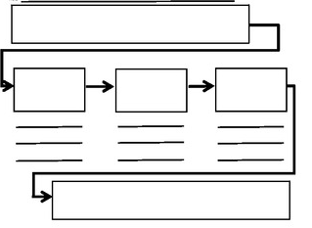
Step 4: Add transition words. | sequence reasons example clarify  First one reason for example to clarify  After furthermore for instance i mean  Lastly in addition one time… In other words
Step 5: Put the paragraph together.  Copy all of your sentences. | 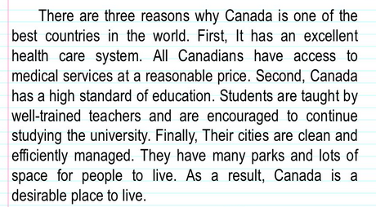
Step 6: Revise and edit your work | 